**ACKNOWLEDGEMENT**

We would like to extend our heartfelt gratitude to **Mrs Bhavika,** whose guidance, expertise, and invaluable support have been instrumental in the successful completion of this project. Their insightful suggestions and constant encouragement have motivated us throughout this journey.

We are deeply grateful to **Dr. Vibha Patel**, Head of the Department, for providing us with the opportunity and resources to undertake this project. Their leadership and vision have been pivotal in shaping our academic and professional endeavors.

Our sincere thanks to **Prof. B. M. Vadher**, Director of **Chhotubhai Gopalbhai Institute of Technology**, for fostering an environment of learning and innovation, which has allowed us to pursue this project with dedication and creativity.

We would also like to thank all the **faculty members of the Department of Computer Engineering** for their continuous support, guidance, and feedback, which have significantly enhanced our understanding and skills throughout our academic journey.

Finally, we are incredibly thankful to our **family and friends** for their unwavering support,patience, and encouragement, without which this project would not have been possible.

**Rushiraj Ravalji (202103103510400)**

**Manav Prajapati (202103103510280)**

**Kevin patel (202103103510275)**

**Rushi kansara (202103103510271)**

# **ABSTRACT**

A collaborative whiteboard website project is an online platform that allows multiple users to simultaneously create, share, and collaborate on visual content in real time. Here's an abstract breakdown of the core components and features of such a project:

## 1. Purpose and Functionality

* **Collaboration**: The primary purpose is to enable real-time collaboration among users on a shared canvas. Users can draw, write, and add objects on the whiteboard together, seeing each other's contributions instantly.
* **Multi-user Interactivity**: Multiple users can join a session, either invited via a link or through a shared workspace, to contribute to the whiteboard. Changes are reflected in real time.
* **Visual Communication**: Users can sketch ideas, create diagrams, annotate images, and brainstorm collectively.

## 2. Key Features

* **Real-time Canvas**: A digital canvas where users can draw freehand, add shapes, text, sticky notes, and images. The updates happen instantaneously, ensuring no lag in collaboration.
* **Tools and Controls**: Drawing tools (pen, eraser, shapes), color palettes, text editing options, and object manipulation features like resizing, rotating, and layering.
* **Undo/Redo Options**: Provides flexibility for users to undo or redo actions, ensuring they can make adjustments as needed.
* **Zoom and Pan**: A scalable canvas where users can zoom in/out and pan across different areas of the whiteboard.
* **Session Management**: Users can save, load, and share sessions. They can invite others through links or integrate it with a team workspace.
* **Export Options**: Users can download the whiteboard as a PDF, image, or other file formats for sharing or archiving.
* **Authentication and User Management**: Secure login for users, allowing personalized workspaces, permission settings, and private or public whiteboards.

## TABLE OF CONTENTS

**ACKNOWLEDGEMENT ...............................................................................................iii**

**ABSTRACT ...................................................................................................................... iv**

**LIST OF FIGURES ........................................................................................................ vii**

**LIST OFTABLES .....................................................................................................…. viii**

**Chapter 1 Introduction...................................................................................................... 1**

1.1 Background ........................................................................................................... 1

1.2 Problem Definition ................................................................................................ 1

1.3 Motivation ............................................................................................................. 1

1.4 Objective ............................................................................................................... 2

1.5 Scope ..................................................................................................................... 3

1.6 Applications .......................................................................................................... 4

**Chapter 2 System Planning ..........................................................................................…. 5**

2.1 Project Development Approach ......................................................................….. 5

2.2 System Modules .............................................................................................…... 5

2.2.1 Module 1 Name........................................................................................….. 5

2.2.1 Module 2 Name......................................................................................….... 5

2.3 Functional Requirements..............................................................................…..... 5

2.4 Non Functional Requirements .......................................................................….... 7

2.5 Hardware and Software Requirements ................................................................ 10

2.6 Timeline Chart..................................................................................................... 11

## TABLE OF CONTENTS

**Chapter 3 System Design................................................................................................. 12**

3.1 Database Schema................................................................................................. 12

3.2 ER Diagram ......................................................................................................... 13

3.3 Use Case Diagram ............................................................................................... 14

3.4 Sequence Diagram............................................................................................... 16

3.5 Activity Diagram ................................................................................................. 18

3.6 Class Diagram/ Component diagram .................................................................. 20

3.7 Data Flow Diagram ............................................................................................. 21

**Chapter 4 Implementation and Testing ......................................................................... 22**

4.1 Snapshots ............................................................................................................. 22

4.2 Test Cases ............................................................................................................ 27

**Conclusion and Future Scope ......................................................................................... 28**

## LIST OF FIGURES

**Figure 2.6: Timeline Chart...........................................................................................… 11**

Figure 1.1 :login/logout Page……………………………………………………………………………………………………… 22

Figure1.2: SignUp Page…………………………………………………………………………………………………………………22

Figure 2.1 SyncSketch Logo……….…………………………………………………………………………………………….…...23

Figure 3.1 Dashboard Page………………………………………………………………………………………………………..…23

Figure 3.1 Creation board Page………………………………………………………………………………………………...….24

Figure 4.1 Rename option in SyncSketch………………………………………………………………………………………24

Figure 4.2 Search option in SyncSketch…………………………………………………………………………………………25

Figure 4.4 All the projects created………………………………………………………………………………………………..25

Figure 5.1 Tools Options……………………………………………………………………………………………………….………26

Figu5.2 Share option…………………………………………………………………………………………………………………….26

## LIST OF TABLES

Table 4.1: Test Cases ......................................................................................................... 27

## 

## Chapter 1 Introduction

**1.1 Background of the Problem Definition**

In the digital age, collaboration and communication have become pivotal for the success of various activities, whether in business, education, or personal projects. Traditional methods of collaboration, such as physical whiteboards and face-to-face meetings, are increasingly being supplemented or replaced by digital solutions. However, existing digital whiteboard applications often lack comprehensive features, are not user-friendly, or fail to provide real-time synchronization effectively. This gap in functionality and user experience necessitates the development of a robust, interactive, and user-friendly online collaborative whiteboard platform.

The background of this problem lies in the need for a tool that can seamlessly integrate multiple collaboration features, ensuring real-time interaction and providing an intuitive user interface. This project aims to address these challenges by developing a collaborative whiteboard website that caters to the needs of diverse user groups, including teams, educators, students, and individuals. The goal is to create a platform that enhances productivity, fosters creativity, and facilitates effective communication in a digital environment

**1.2 Problem definition:**

A **collaborative whiteboard website** is a web-based platform that allows multiple users to simultaneously interact with a digital canvas in real-time. Users can draw, write, and manipulate objects on the board to collaborate on tasks like brainstorming, planning, or visualizing ideas. The platform can be used for various purposes, including business meetings, educational instruction, and team collaboration.

**Lack of Real-Time Collaboration:** Many teams, educators, and remote workers require effective tools for visual communication, brainstorming, and collaboration. Traditional tools such as email or chat applications are insufficient for real-time, visual brainstorming and idea development. There is a need for a platform that facilitates synchronous collaboration across distributed teams.

**1.3 Motivation:**

The motivation behind creating a **collaborative whiteboard website project** typically stems from several key factors:

1. **Facilitate Real-time Collaboration:** 
   * + **Problem**: Traditional methods of brainstorming or collaborating (in-person whiteboards, emails, phone calls) are limited by geography and time.
     + **Solution**: A collaborative whiteboard allows multiple users from different locations to interact in real-time, improving communication, especially for remote teams. It offers the flexibility to work together as if they were in the same room, creating, editing, and sharing ideas seamlessly.
2. **Enhance Creativity and Idea Sharing:** 
   * + **Problem**: Creative brainstorming sessions can be less effective when done through text or static communication tools (e.g., chat or email).
     + **Solution**: A visual, interactive platform helps users share their ideas more fluidly, allowing for drawing, writing, and adding visual elements. This can improve the creativity of team members and enable spontaneous sharing of concepts.
3. **Support Visual Learning and Problem Solving:** 
   * + **Problem**: Many people understand and solve problems better when they visualize information. Traditional tools may not allow for effective visual learning and problem-solving in remote settings.
     + **Solution**: A collaborative whiteboard website supports diagrams, flowcharts, sketches, and other visual aids, making complex concepts easier to grasp.

**1.4 Objective:**

The objective of a collaborative whiteboard website project is to create an online platform that allows multiple users to interact and collaborate in real time on a shared digital canvas. The primary goals include:

* + 1. **Real-time Collaboration**: Facilitate simultaneous drawing, writing, and editing on a shared whiteboard where users can contribute from different locations.
    2. **User-friendly Interface**: Provide an intuitive, easy-to-use interface that mimics the experience of a physical whiteboard, supporting drawing tools, text input, and other media elements.
    3. **Seamless Communication**: Allow users to communicate through integrated features like chat, voice, or video, ensuring smooth collaboration and idea sharing.
    4. **Cross-platform Accessibility**: Make the platform accessible across multiple devices (desktop, tablet, mobile) and operating systems, enabling users to collaborate anytime, anywhere.
    5. **Version Control and History Tracking**: Implement a system to track changes, allowing users to revert to previous versions of the whiteboard and view the history of edits.
    6. **User Management and Permissions**: Provide a system where users can control who can view or edit the board, and manage participants effectively.
    7. **Integration with Other Tools**: Support integration with other productivity tools like Google Drive, Slack, or project management software, to streamline workflow.
    8. **Data Security and Privacy**: Ensure the platform is secure, with encrypted data transfer and proper access controls to protect users' data.

This platform is useful for team brainstorming sessions, educational purposes, remote meetings, and creative collaboration, enhancing productivity and teamwork in virtual environments.

**1.5 Scope:**

The Collaborative Whiteboard Website project is envisioned to create an advanced, interactive, realtime, browser-

based whiteboard application. The primary focus of this project is to develop a platform where multi ple users can simultaneously collaborate visually and creatively on a shared digital canvas. Here’s an in-depth look at the scope:

1. **Purpose and Objectives**:

* + - * **Interactive Platform**: The core aim is to develop an online space that supports a high ly interactive user experience, enabling users to engage in realtime visual collaboration.
      * **Real-Time Collaboration**: The platform will be designed to facilitate realtime updates and interactions, ensuring seamless and synchronous collaboration am ong multiple users.

2. **Target Audience**:

* + - * **Teams**: Business and professional teams can use the platform for collaborative brain storming, project planning, and ideation sessions.
      * **Educators and Students**: The platform will support teaching and learning activities, p roviding an interactive space for educators and students to engage with content and collaborate on projects.
      * **Individuals**: For personal projects, creative sketching, and visual communication, the platform offers a versatile and dynamic environment.

3. **Core Functionalities**:

* + - * **Drawing Tools**: The application will include a variety of drawing tools, such as pencil s, brushes, shapes, and colors, to cater to different creative and professional needs.
      * **Text Input**: Users will be able to add text to the canvas, enhancing the ability to ann otate, label, and create text-based content.
      * **Image Uploads**: The ability to upload images will allow users to incorporate external visual elements, enriching the collaborative and creative experience.
      * **Real-Time Interaction**: The platform will enable realtime collaboration, allowing multiple users to work on the same whiteboard simulta neously, with updates reflected instantly for all participants.

1. **Use Cases**:
   * + - **Brainstorming**: Teams can use the whiteboard for brainstorming sessions, capturing ideas visually and collaboratively.
       - **Sketching and Diagramming**: The platform supports sketching and diagramming, ma king it ideal for creating flowcharts, mind maps, and other visual representations.
       - **Visual Communication**: The application will facilitate visual communication, allowing users to share and develop ideas visually in a collaborative setting.

**1.6 Application:**

* + - **Multi-user Collaboration:** Multiple users can work on the same whiteboard simultaneously.
    - **Real-Time Sync:** Changes made by one user are immediately visible to others without page refresh.
    - **Presence Indicators:** Show who is currently viewing or editing the board.
    - **User Cursors:** Display a unique cursor for each participant, with their name or profile icon.

## Chapter 2 System Planning

**2.1 Project Development Approach**

We chose **RAD (Rapid Application Development**) as our Software Development Model **Advantages :**

* Given the time frame of 2 months we would need the rapid application within the given time frame and RAD fits best to our scenario.
* Collaborative approach with one time release fits the Rapid Application Development Model

**Disadvantage :**

* Repetitive bug fixes and Updates aren't possible in this Model as it focuses on Rapid development of an application and does not cover the Updates part.
  1. **System Modules**

In our project, we focused on creating a Colabrative whiteBoad System made up of three main modules: Candidate, Admin, and Viewers. These modules work in a hierarchical structure to ensure efficient data management and smooth user interactions.

**2.3 Functional requirements:**

When designing the functional requirements for a collaborative whiteboard website, the goal is to ensure users can create, share, and work together in real-time on visual projects. Here’s a breakdown of key functional requirements:

### 1. User Authentication and Authorization

* **User Registration:** Users can create accounts via email, social media, or third-party authentication providers (e.g., Google, Facebook).
* **User Login/Logout:** Users can securely log in and log out.
* **Password Management:** Ability to reset and manage passwords securely.
* **Role Management:** Assign different roles like admin, creator, editor, viewer, etc.

### 2. Dashboard and User Interface

* **User Dashboard:** Users can view and manage their created or shared boards.
* **Whiteboard Creation:** Users can create a new whiteboard session or project.
* **Template Selection:** Optional pre-built templates for common use cases (e.g., flowcharts, mind maps).
* **Real-time Collaboration Interface:** Users can access an intuitive interface to draw, write, or edit content.

### 3. Whiteboard Functionalities

* **Drawing Tools:** Pen, pencil, shapes, eraser, etc.
* **Text Editing:** Ability to add and format text (font size, color, alignment).
* **Sticky Notes:** Add sticky notes with editable text.
* **Images and Files:** Upload images or files to the whiteboard.
* **Zoom and Pan:** Ability to zoom in/out and move around the whiteboard.
* **Layers or Z-Index:** Manage items layered on the whiteboard (bring to front, send to back).
* **Grid/Guidelines:** Optional grid view for alignment and structure.

### 4. Real-Time Collaboration

* **Multi-user Collaboration:** Multiple users can work on the same whiteboard simultaneously.
* **Real-Time Sync:** Changes made by one user are immediately visible to others without page refresh.
* **Presence Indicators:** Show who is currently viewing or editing the board.
* **User Cursors:** Display a unique cursor for each participant, with their name or profile icon.

### 5. Communication Tools

* **Chat Functionality:** Integrated text chat within the whiteboard session.
* **Audio/Video Conferencing:** Optional feature for live video or voice communication during collaboration.
* **Commenting/Annotations:** Ability to comment on specific sections of the whiteboard or leave annotations.

### 6. Board Management

* **Save and Export Options:** Users can save their boards and export them as PDF, PNG, SVG, or other formats.
* **Version Control:** Track changes and access previous versions of the whiteboard.
* **Board Sharing:** Share boards via unique links, with options for read-only or editable access.
* **Access Control:** Define permissions (view, edit, comment) for each user or group.

### 7. Notifications and Alerts

* **Activity Notifications:** Notify users of updates, such as when someone joins or edits a shared board.
* **Email Notifications:** Option for email alerts when significant changes occur.
* **In-App Notifications:** Instant notifications within the platform for real-time updates.

### 8. Search and Filters

* **Board Search:** Users can search for specific boards by name or content.
* **Content Filtering:** Filter content on the whiteboard (e.g., show only text, images, etc.).

* 1. **Non-functional requirements:**

Non - functional requirements (NFRs) focus on a system's operational qualities such as performance, security, usability, and scalability. These requirements are crucial for ensuring the system's reliabiliy, efficiency, and user satisfaction beyond its core functionalities. Here are common nonfunctional requirements for a collaborative whiteboard website project, elaborated in detail:

### 1. Performance

* **Response Time**: The system should respond to user inputs such as drawing or erasin g within 100 milliseconds. This ensures a realtime collaborative experience, which is essential for user satisfaction and productivit y.
* **Latency**: The maximum acceptable latency between multiple users collaborating on t he whiteboard should be under 500 milliseconds. Low latency is critical for maintaini ng a seamless and interactive experience.
* **Scalability**: The system must handle an increasing number of users and concurrent s essions without significant degradation in performance. For example, it should supp ort up to 1,000 concurrent users. Scalability ensures that the system can grow and a ccommodate more users over time.
* **Load Balancing**: The system should distribute loads evenly across servers to maintai n optimal performance under high traffic conditions. Load balancing prevents any sin gle server from becoming a bottleneck, ensuring smooth operation and responsiven ess.

### 2. Availability and Reliability

* **Uptime**: The system should be available 99.9% of the time, ensuring minimal downti me for users. High availability is critical for maintaining user trust and satisfaction.
* **Fault Tolerance**: In case of server failure, the system should recover within 1 minute to minimize disruption to active sessions. Fault tolerance ensures that the system ca n continue operating smoothly even in the event of hardware or software failures.
* **Backup and Recovery**: User sessions and whiteboard data should be backed up ever y 5 minutes. In case of any failure, the recovery of data should occur within 10 minut

es. Regular backups and efficient recovery mechanisms are essential for protecting u ser data and maintaining continuity of service.

### 3. Security

* **Authentication**: All users must authenticate via secure login methods such as OAuth, SSO (Single Sign-On), or multi-

factor authentication. Strong authentication methods are crucial for ensuring that o nly authorized users can access the system.

* **Data Encryption**: All data transmissions, including user inputs and drawings, should be encrypted using TLS (Transport Layer Security). Encryption protects the confidenti ality and integrity of data during transmission.
* **Authorization**: Rolebased access control (RBAC) should be implemented to ensure that only authorized users (e.g., owners, collaborators, viewers) can perform specific actions on the white board. Authorization mechanisms help prevent unauthorized access and actions.
* **Data Privacy**: The system should adhere to privacy standards such as GDPR (General Data Protection Regulation) to protect users' personal information and content. Dat a privacy compliance ensures that user data is handled responsibly and ethically.
* **Session Management**: Sessions should time out after 30 minutes of inactivity to pre vent unauthorized access. Session management practices help safeguard user accou nts and data.

### 4. Scalability

* **Horizontal Scaling**: The system should support the addition of more servers to handl e increasing loads without compromising performance. Horizontal scaling ensures th at the system can expand its capacity as needed.
* **Elasticity**: The system should be able to automatically scale up or down depending o n user activity and traffic. Elasticity allows the system to efficiently manage resource s and costs by adjusting capacity based on demand.

### 5. Usability

• **Intuitive Interface**: The whiteboard interface should be simple and easy to use, allowing users to start drawing or collaborating without a steep learning curve. An intuitive interface enhances the user experience and productivity.

### • Cross-platform support: The application should work seamlessly on different devices, including desktops, tablets, and mobiles, as well as various operating systems such as Windows, macOS, iOS, and Android. Cross-platform support ensures that users can access the whiteboard from any device and operating system.

• **Accessibility**: The interface should comply with accessibility standards such as WCAG 2.1 (Web Content Accessibility Guidelines), making it usable for people with disabilit ies. Accessibility ensures that the system is inclusive and can be used by a diverse ra nge of users.

### 6. Maintainability

* **Modular Design**: The system should have a modular architecture to facilitate easier maintenance, updates, and troubleshooting. A modular design allows developers to make changes and enhancements without affecting the entire system.
* **Documentation**: Comprehensive documentation for both developers and users shou ld be maintained to ease future development and issue resolution. Welldocumented systems are easier to understand, maintain, and extend.
* **Code Quality**: The system should follow best practices in software engineering, inclu ding code versioning, testing, and linting to maintain high code quality and reduce te chnical debt. High code quality ensures that the system is reliable, maintainable, and scalable.

### 7. Interoperability

* **API Integrations**: The whiteboard should provide APIs for integrating with third-party services (e.g., Google Drive, Microsoft Teams) and other collaboration tools.
* **File Format Compatibility**: The system should support importing and exporting whiteboard data in common formats (e.g., PDF, PNG, SVG).

### 8. Compliance

* **Data Protection Laws**: The system should comply with relevant data protection regulations, including GDPR, CCPA, and other applicable laws in the regions where the users are located.
* **Audit Logs**: The system should maintain logs of user actions (e.g., login attempts, changes made on the whiteboard) for auditing and tracking purposes.

### 9. Localization and Internationalization

* **Multilingual Support**: The platform should support multiple languages to accommodate a global user base.
* **Timezone Handling**: Collaborators working across different time zones should have the whiteboard session reflect their local time accurately.

### 10. Extensibility

* **Plugin Support**: The system should allow for future extensions (e.g., additional tools, integrations) without significant rework to the core system.
* **Customizations**: Users should have the option to customize their whiteboard interface (e.g., color themes, toolsets).

**2.5 Hardware and Software requirement:**

**Hardware Requirements :**

Processor : Intel i5 / Ryzen 5

RAM : 4GB or Higher

Hard Disk : 20GB

**Software Requirements :**

Operating System : Windows/Linux

Back-end : Nodejs

Database : MongoDB

Frameworks : ReactJs, Nextjs, Convex

Front-End : Html, Css3, Tailwind, Typescript, Shadecn/ui

**2.6 Timeline Chart**

**ACTIVITY**

**22**

**AUG**

**-**

**25**

**AUG**

**26**

**AUG**

**-**

**15**

**SEP**

**16**

**SEP**

**-**

**30**

**SEP**

**1**

**OCT**

**-**

**20**

**OCT**

**Requirement**

**Analysis**

**Designing**

**Implementation**

**Testing**

**Report**

**Generation**

Figure 2.1 Time Chart

**Chapter 3 System Design**

**3.1 Database schema**

A database schema is the skeleton structure that represents the logical view of the entire database. It defines how data is organized and how relationships among data are structured. In essence, it serves as the blueprint for how data is stored, managed, and accessed within the database.

Components of a Database Schema

Tables: These are the foundational entities of the schema. Each table represents a specific entity (like 'Customers', 'Orders', or 'Products') and is composed of rows and columns

Fields (Columns): Each table consists of fields that define the type of data that can be stored. For example, a 'Customer' table might have fields like CustomerID, Name, Email, and Phone.

Relationships: These define how tables interact with each other. Common relationships include:

One-to-Many: A single record in one table is related to multiple records in another (e.g., one customer can have multiple orders).

Many-to-Many: Records in one table can be related to multiple records in another table and vice versa (handled using a junction table).

One-to-One: A single record in one table is related to a single record in another.

Constraints: Rules applied to ensure data integrity. Common constraints include:

Primary Key: A unique identifier for each record in a table.

Foreign Key: A field in one table that links to the primary key in another table, establishing a relationship between the two.

Unique: Ensures all values in a column are unique.

Not Null: Ensures a column cannot have a null value.

Benefits of a Well-Designed Schema

Data Integrity: Ensures accuracy and consistency of data through constraints.

Efficient Queries: Optimizes the performance of database operations by organizing data logically.

Scalability: Facilitates growth and changes in the database structure without major overhauls.

**3.2 ER diagram:**

The diagram illustrates the interactions within a collaborative whiteboard system involving two users ( User 1 and User 2) and the central collaborative board (Collab), connected through a server. Each use r's information comprises Username, Email ID, Password, and a unique Whiteboard PIN.

1. User Information: Both users have their details, including Username, Email ID, Password, and Whiteboard PIN, clearly specified. These attributes are crucial for user identification and auth entication.
2. Connection to Collaborative Board (Collab): Each user is connected to the central collaborativ e board. This connection facilitates realtime collaboration, allowing multiple users to interact simultaneously on the same platform.
3. Server Interaction: The collaborative board (Collab) is directly linked to the server. The server plays a pivotal role in managing user authentication, data storage, and ensuring seamless real -time updates across users’ activities on the collaborative board.
4. Collaboration Process:
   * + User Authentication: Users first authenticate themselves using their Username, Email ID, and Password.
     + Whiteboard PIN: Each user utilizes their unique Whiteboard PIN to join the collaborati ve session on the board.
     + Real-

Time Collaboration: Once connected, both users can interact in real time on the colla borative board, with the server managing and synchronizing the activities.

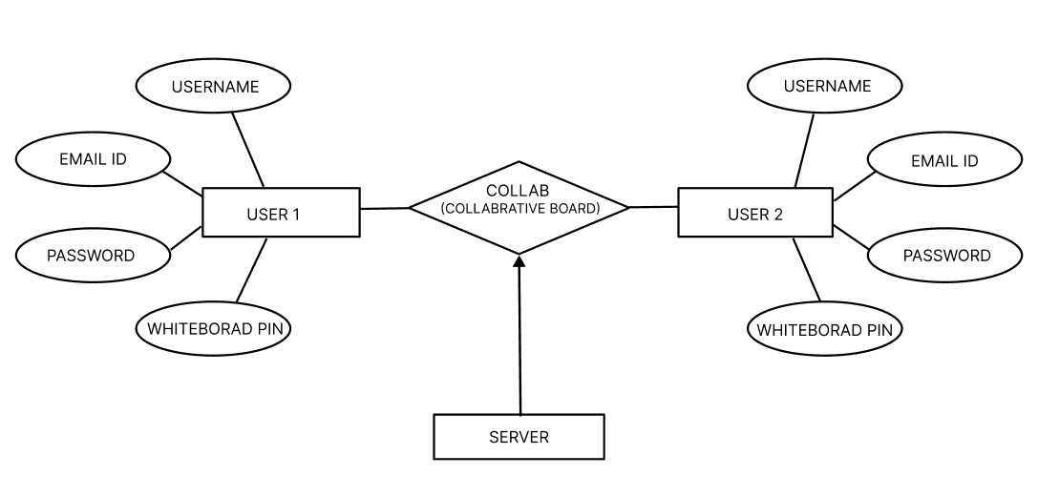

Figure 3.1: ER Diagram

**3.3 Use diagram:**

The diagram outlines the step-by-step process involved in utilizing a collaborative whiteboard application. This process facilitates realtime interaction and collaboration between users. The workflow can be broken down into several key stages:

1. Sign In: The user begins by signing in to the application, providing essential details such as em ail address and contact number for authentication. This information is sent to the server for v erification.
2. Log In: Once authenticated, the user proceeds to log in to the application. This step also invol ves server interaction to confirm the user’s credentials.
3. Navigate to New Project: After successful login, the user can navigate to a new project. This st ep enables the user to initiate a new collaborative session.
4. Select Tools: Within the new project, the user has access to a variety of tools, including option s for creating a blank board, a flowchart, or a mind map. The selection of tools is based on the specific needs of the project.
5. Share Whiteboard Pin: To invite other users (User 2) to collaborate, the user generates and sh ares a unique whiteboard pin. This pin is crucial for enabling other users to join the collaborati ve session.
6. Collaborative Interaction: The final step involves collaborative interaction on the whiteboard. Users can engage in realtime brainstorming, idea sharing, and project development on the platform.

Throughout this process, the server plays a pivotal role in verifying user credentials and facilitating sea mless collaboration. This structured workflow ensures an efficient and effective collaborative experien ce, making the application a valuable tool for teamwork and project management.

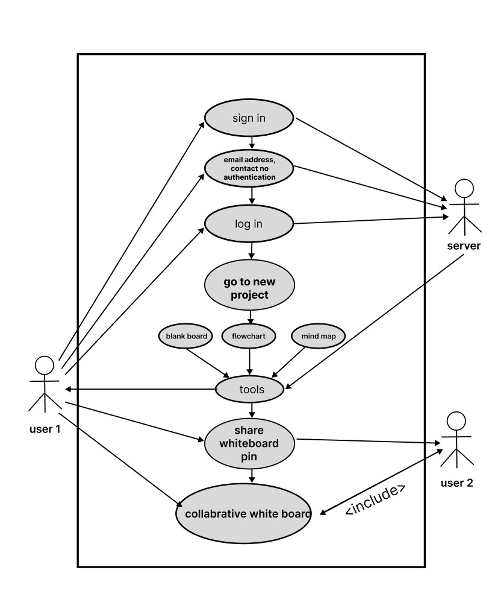

Figure3.2: Use diagram

**3.4 Sequence Diagram**

Components:

1. User: The person or client trying to access the application.
2. Web Server: The server that handles requests from the user and interacts with the database to process these requests.
3. Database: The storage system containing user data and credentials used for validation.

Sequence Flow:

1. Login Request (User to Web Server):

o The sequence begins when the User sends a Login request to the Web Server. This represents the user attempting to log into the system, typically by submitting credentials such as a username and password.

1. Validation Request (Web Server to Database):

o Once the web server receives the login request, it sends a Validate request to the Database. This is where the web server verifies the user’s credentials (usually by comparing them with the records stored in the database).

1. Validation Response (Database to Web Server):

o After the database completes the validation (e.g., checking if the username and password match), it sends a validation result back to the web server. This step determines whether the login attempt is successful or not.

1. Response (Web Server to User):

o Finally, the Web Server sends a Response back to the User. This response could indicate whether the login was successful (allowing the user to proceed) or failed

(perhaps with an error message to retry or inform the user of incorrect credentials).

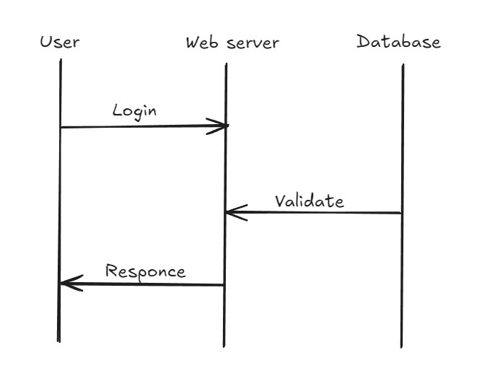

Figure 3.3 Sequence Diagram

**3.5 Activity Diagram**

Activity Diagram of SyncSketch Web App

1. User Accesses SyncSketch
   * + Action: The user opens the SyncSketchweb app.
     + Description: The system loads the homepage and presents the initial interface to the user.
2. User Logs In
   * + Action: The user enters their login credentials.
     + Description: The system verifies the credentials against the stored data to ensure authenticity . If valid, the user is granted access; if not, an error message is displayed.
3. Dashboard Interaction
   * + Action: The user navigates through the dashboard.
     + Description: The dashboard displays ongoing projects and provides options for navigation to d ifferent sections. The user selects a project to open.
4. Project Creation
   * + Action: The user creates a new project.
     + Description: The user clicks on "Create New Project" and either selects a template or starts fr om scratch. The user customizes the project by adding elements and then saves it.
5. Collaborating on Project
   * + Action: The user invites team members to collaborate.
     + Description: Invitations are sent to team members. Once accepted, team members join the pr oject. Users can then collaborate through realtime editing and communication via chat or video calls.
6. Managing Tasks
   * + Action: The user manages tasks within the project.
     + Description: The user adds, assigns, and prioritizes tasks. The system tracks progress, ensuring all team members are updated on the status of tasks.
7. File Management
   * + Action: The user uploads and retrieves files.
     + Description: Files and documents are uploaded to the project. The system ensures secure stor age and allows users to download files as needed.
8. Settings Adjustment
   * + Action: The user adjusts settings and preferences.
     + Description: The user updates their profile information and notification preferences in the set tings section. The system saves these changes to customize the user's experience.
9. Logging Out
   * + Action: The user logs out of the web app.
     + Description: The system terminates the user session and redirects them to the login page.

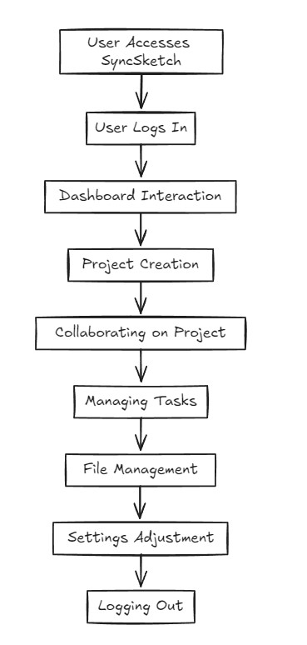

Figure:3.4 Action Diagram

**3.6 Class Diagram**

The class diagram for theSyncSketch web app consists of several key classes and their relationships. The User class, with attributes like userID, username, password, and email, has methods for logging in, logging out, and updating the profile. The Dashboard class, linked one-to-one with the User class, manages user-specific dashboards and can display projects and navigate sections. The Project class, which can be created by a user, holds attributes like projectID, name, createdDate, and createdBy, and methods for creating, saving, and deleting projects. Each project can have multiple Tasks, described by attributes such as taskID, description, assigned, and due Date, and methods to add, update, and remove tasks. Files are also associated with projects, featuring attributes like fileID, fileName, and filePath, with methods for uploading, downloading, and deleting files. Lastly, the Settings class, tied one-to-one with the User class, stores user preferences and allows updating settings. These classes and their interactions provide a structured way to manage users, projects, tasks, files, and settings within the SyncSketch web app

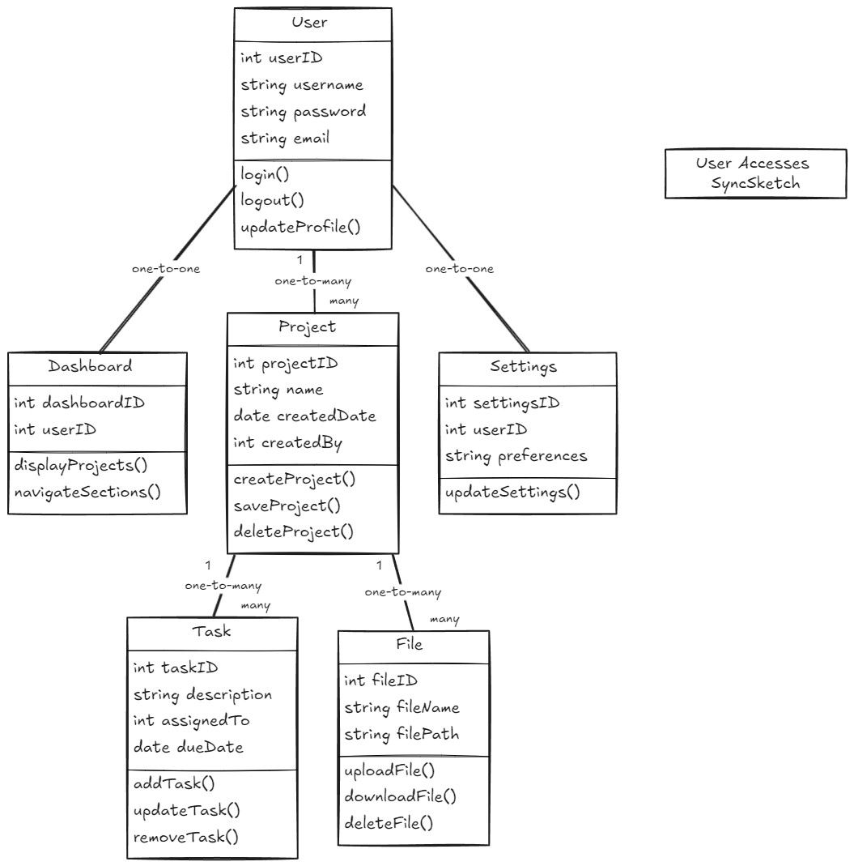

Figure 3.5 Class Diagram

**3.7 Data Flow Diagram**

The data flow diagram for the SyncSketch web app illustrates how information flows between various components. The User interacts with the User Interface, which communicates with the Server to proc ess requests. The server performs Processes such as User Authentication, Project Management, Task Management, File Management, and Settings Management. Each process interacts with specific Data Stores: the User Data Store holds user credentials and profiles, the Project Data Store contains project details, the Task Data Store stores task information, the File Data Store manages uploaded files, and t he Settings Data Store keeps user preferences. This diagram highlights the interconnectedness of com ponents and ensures a seamless user experience within the SyncSketch web app.

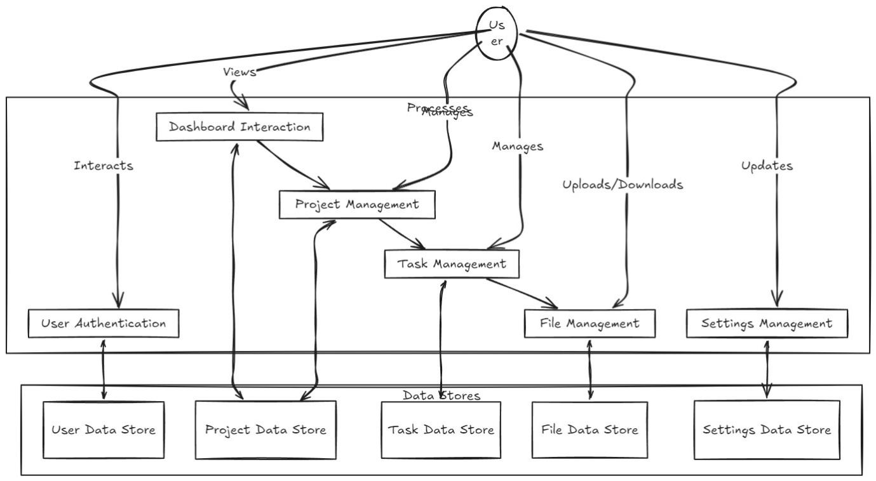

Figure 3.6 Data Flow Diagram

**Chapter – 4 Implementation and Testing**

**4.1 Snapshots:**

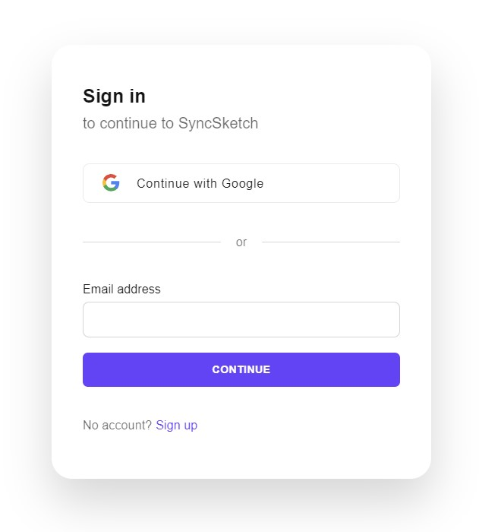

Figure 4.1 login/logout Page

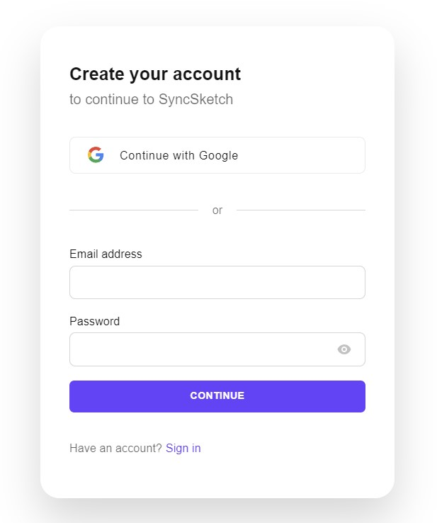

Figure4.2: SignUp Page



Figure 4.3 SyncSketch Logo

Figure 4.4 Dashboard Page

Figure 4.5 Creation board Page

Figure 4.6 Rename option in SyncSketch

Figure 4.7 Search option in SyncSketch

Figure 4.8 Inviting different users button in SyncSketch

Figure 4.9 All the projects created

Figure 4.10 Tools Options

Figuer 4.11 Share option

**4.2 Test Case:**

Sample test cases are given as below:

**Table 4.1: Test Cases**

|  |  |  |  |  |  |
| --- | --- | --- | --- | --- | --- |
| **TestID** | **Case** | **Test Data** | **ExpectedResult** | **ActualResult** | **Pass/fail** |
| 1 | Home Page | Login. | Login in using clerk. | Login using Clerk. | Pass |
| 2 | Register as admin | Register as admin. | -Admin is able to register.  - Admin is ablet to edit | * Admin is able to register. * Admin is ablet to edit | Pass |
| 3 | Register as candidate | Register as candidate. | -Candidate gets registered -Candidate Count and details show. | Candidate Count and details show . | Pass |
| 4 | Share | - Is Able to share to screen to the different users | - Number of Candidates with their id is visible . | - Number of Candidates with their id is visible. | Pass |
| 5 | Edit | -Who can edit. | -Only authorized id’s can edit or make changes. | -Only authorized id’s can edit or make changes. | Pass |

Figure 4.2.1 Test Case Diagram

**Conclusions and Future Scope**

### Conclusion

The Collaborative Whiteboard Website project is set to revolutionize the way multiple users interact and collaborate visually in real-time. By providing a comprehensive suite of features such as drawing tools, text input, image uploads, and real-time interaction capabilities, this platform will cater to the diverse needs of teams, educators, students, and individual users. The project's focus on nonfunctional requirements, including performance, availability, reliability, security, scalability, usability, and maintainability, ensures a robust, efficient, and user-friendly experience.

This whiteboard application will not only enhance productivity and creativity but also foster better communication and collaboration among users. By adhering to high standards in design and implementation, the platform will offer a reliable and secure environment for visual brainstorming, sketching, diagramming, and more. Overall, the Collaborative Whiteboard Website promises to be an invaluable tool for modern digital collaboration, setting a new benchmark in online interactive platforms.

### Future Scope

In future developments, the project aims to integrate a marketplace feature. This enhancement will allow users to search for, view, and purchase various types of mind maps tailored to their specific to pics. By offering a diverse range of mind maps, the platform will provide users with valuable resourc es to aid their collaborative efforts and enhance their productivity. This marketplace will not only enr ich the user experience but also position the platform as a comprehensive solution for visual collabor ation and creative brainstorming.